Elaine Joseph

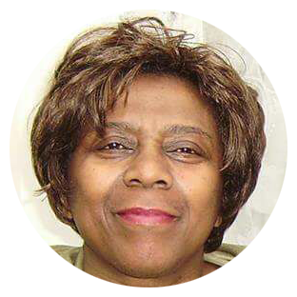

Elaine Joseph is an author, poet, and renowned Storyteller. She has worked within infant and primary schools in London, Wokingham, and Bracknell Forest. Her toe-tapping, tongue-twisting, interactive and unique brand of Storytelling was enjoyed by the children in Langenhagen, Germany. Her sessions are lively, dramatic, and bursting with energy! They allow the children to imagine, participate, and bring alive the characters in the story.
Elaine has written and published several books and is widely known for her bestseller ‘Dreamstealer,’ a children’s book which was published in seven different languages and has sold over 5,000 copies. She has self-published a manual for young people, “The Young Adult Development Manual” and a book for children called “The Playground” which was written to enhance the school curriculum. The book speaks about children’s experiences in the playground and encourages them to express their feelings and play in an engaging manner.
Elaine states “I view stories as a sensory experience. If a story is told well, the children will hear, see, feel, smell, and touch the people and objects through their imagination. It is the realisation to the child of his/her power to create. When the children write they are Writing Without Walls.

